*Proletarians of all countries, unite!*

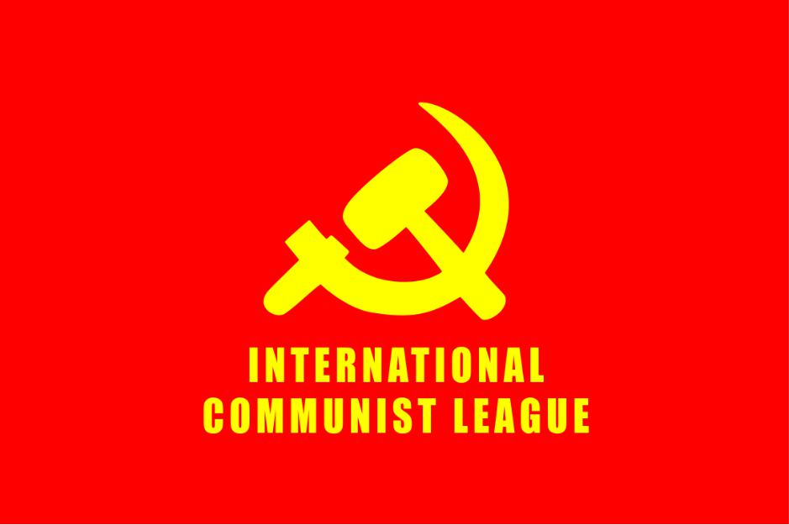

**COMRADE LENIN, LEADING LIGHT OF THE INTERNATIONAL PROLETARIAT AND GREAT TEACHER OF MARXISM-LENINISM-MAOISM, ILLUMINATES THE PATH OF UNITY FOR THE INTERNATIONAL COMMUNIST MOVEMENT**

"**We are those who form the army of the great proletarian strategist, the army of Comrade Lenin. There is nothing higher than the honour of belonging to this army.**"(Stalin)

As the pages of History show, on the 21st of January 1924, Comrade Lenin, the great leader of the working class and oppressed peoples of the world, the second great milestone of Marxism-Leninism-Maoism, became immortal and left behind a great legacy of incalculable value. The teachings of Comrade Lenin, who transformed the "world of the future", the foundations of which were laid by Marx and Engels, from an abstract possibility into a concrete reality, are still fully relevant after a century and great upheavals in the world. In order to position oneself correctly in the class struggle, one must accept this "actuality" and orient oneself to it. This "actuality" is at the same time a cure against reformist, revisionist and parliamentary cretinism, which means capitulation and compromise with ruling ideologies of any kind. It is the guarantee of faith and determination that a communist world can be created.

**LENIN AS THE TEACHER OF COMMUNISM WHO BROKE THE ICE AND PAVED THE WAY AGAINST INTERNATIONAL REACTION AND REVISIONISM**

To correctly identify the contradictions in the history of the class struggle, to grasp the moments of historical rupture and to be ready in these moments of rupture was the most outstanding feature of comrade Lenin's entire struggle up to his immortality. After the death of Marx and Engels, the leadership of the international proletariat was for a long time taken over by the opportunism of the Second International, and in the words of comrade Stalin: **"A period in which the parties of the Second International were not able to take over the theoretical struggle to liberate the international proletariat and the oppressed peoples of the world from the influence of these opportunist and class-compromising social-democrats. In addition to the theoretical struggle for the liberation of the international proletariat and the oppressed peoples of the world, with the foundation of the Communist International he developed a form of organization and struggle appropriate to the dynamics of the class struggle in the new period of capitalism. "**

Comrade Lenin transformed the Communist Party and the Communist International into an instrument of war against the bourgeoisie by liberating the Communist Party and the movement of the Communist International from the shackles of legal forms of struggle**: "Instead of a revolutionary policy, there was flabby philistinism and sordid political bargaining, parliamentary diplomacy and parliamentary scheming. For the sake of appearances, of course, “revolutionary” resolutions and slogans were adopted..."** butwhich it "keeps in the drawers of offices", freed from the grip of legal forms of struggle.

**“Meanwhile, a new period of imperialist wars and of revolutionary battles of the proletariat was approaching. The old methods of fighting were proving obviously inadequate and impotent in face of the omnipotence of finance capital. It became necessary to overhaul the entire activity of the Second International, its entire method of work, and to drive out all philistinism, narrow-mindedness, politicians’ tricks, renegacy, social-chauvinism and social-pacifism. It became necessary to examine the entire arsenal of the Second International, to throw out all that was rusty and antiquated, to forge new weapons. Without this preliminary work it was useless embarking upon war against capitalism. Without this work the proletariat ran the risk of finding itself inadequately armed, or even completely unarmed, in the future revolutionary battles. The honour of bringing about this general overhauling and general cleansing of the Augean stables of the Second International fell to Leninism.”.** (Stalin, Foundations of Leninism)

Comrade Lenin, with his genius, grasped the core of the contradiction and realized that the struggle against the bourgeoisie cannot be sufficiently effective and successful without shaking off the burdens that weigh on the back of the international proletariat, without fighting revisionism and opportunism, without showing the masses the true character of these views in theory and practice, without isolating them as far as possible. By establishing the dialectical and necessary link between the "internal struggle" and the "external struggle", he waged the double struggle.

Comrade Lenin left us communists the extremely important lesson that the struggle against revisionism and opportunism cannot be separated from the struggle against imperialism and all forms of ruling reaction. On the contrary, the struggle against imperialism must be purged of revisionism and opportunism.

**HOLD HIGH THE TEACHINGS OF LENIN WITHIN THE SHARPENING CONTRADICTIONS OF THE IMPERIALIST SYSTEM**

The imperialist system, which comrade Lenin analyzed in detail at the beginning of the 20th century, has survived in the past period, but its contradictions are sharpening and it is in a spiral of insoluble antagonist contradictions. Although the dissolution of the USSR and the process of integration into the capitalist system that China went through prevented the contradictions from exploding for a while, the law of unequal development of capitalism continued and the inter-imperialist rivalry developed to the stage of "disintegration" with regional wars. This shows the crisis the system is in and that the previous "solutions" no longer work. The imperialists, who for a long time maintained their crisis by shifting the burdens of the system to the semi-colonies and deepening the plundering of the semi-colonies, have also reached a dead end here.

One of the explosive points of the inherent problems of the imperialist system, which have developed in accordance with Lenin's definition of imperialism, is that the inter-imperialist struggle, which has manifested itself in various forms in recent years, is currently being fought out in regional wars. When Lenin enumerated the contradictions of imperialism, he mentioned the inter-imperialist contradiction as one of the three most important contradictions.

We can see that developments are in line with comrade Lenin's observations on the character and contradictions of imperialism: **"The second contradiction is the contradiction among the various financial groups and imperialist Powers in their struggle for sources of raw materials, for foreign territory. Imperialism is the export of capital to the sources of raw materials, the frenzied struggle for monopolist possession of these sources, the struggle for a re-division of the already divided world, a struggle waged with particular fury by new financial groups and Powers seeking a “place in the sun” against the old groups and Powers, which cling tenaciously to what they have seized. This frenzied struggle among the various groups of capitalists is notable in that it includes as an inevitable element imperialist wars, wars for the annexation of foreign territories. This circumstance, in its turn, is notable in that it leads to the mutual weakening of the imperialists, to the weakening of the position of capitalism in general, to the acceleration of the advent of the proletarian revolution and to the practical necessity of this revolution."** (Stalin,Foundations of Leninism).

Russia and China, the former socialist countries that have given the imperialist system a respite with their new markets, have become the main players in the inter-imperialist rivalry, in contention with the hegemonic power United States. This means that the extent and nature of the contradictions have increased with the growing involvement of new and powerful players in the struggle for the redistribution of territories. The big confrontation with the invasion of Russian imperialism in Ukraine took place against this background. It is foreseeable that this tendency will deepen and spread further. As long as there is no direct confrontation between the imperialists, the areas where the wars of division are waged are semi-colonies and colonies. The semi-colonies and oppressed peoples of the world will continue to pay the price of these wars until the imperialists declare direct war on each other.

With this the *division of world into a handful of imperialist nations and a majority of oppressed countries –* masterfully analyzed by Lenin*-* deepen even more. The third contradictionssharpens with the imperialist pillage and plunder, and the semi-colonial and semi-feudal rise in powerful Wars of National Liberation and People’s Wars that shake the imperialist system.

In parallel to the process in which imperialism is going under the inter-imperialist contradictions, and the contradiction imperialist countries and oppressed people’s and

nations; all parts of the ruling system, especially the imperialist states, are becoming more centralized, militaristic and warlike than before, paving the way for all fascist sentiments to bring society into a corresponding ideological format. This is fulfilled either by so called right-wing extremist or under the veil of social democratic or liberals parties. The communists and the oppressed peoples of the world, faced with the reality of a system that is becoming more reactionary and aggressive by the day, need a Leninist Party to lead the proletariat's struggle for political power, as outlined by comrade Lenin, in order to organize a strong resistance against this reaction. Only such a Party, today a Marxist-Leninist-Maoist one, can lead an irreconcilable struggle against the bourgeoisie.

**LENIN'S GREAT LEGACY, THE LENINIST CONCEPTION OF THE PARTY: THE GENERAL STAFF OF THE PROLETARIAT**

**A revolution is not a dinner party, or writing an essay, or painting a picture, or doing embroidery; it cannot be so refined, so leisurely and gentle, so temperate, kind, courteous, restrained and magnanimous. A revolution is an insurrection, an act of violence by which one class overthrows another.** *(Mao Zedong).*

It is crucial how the communists define the existing contradictions and how they position themselves in the face of developments. In the hundred years since the death of comrade Lenin, the imperialists have transformed their ruling structures into even bigger war machines. Their armies, police, secret services etc. are equipped with capabilities incomparable to those of the past. On the other hand, a considerable part of those who call themselves "communists" or "revolutionaries" ignore this reality (even if it seems to be

theoretically accepted) and are far from positioning themselves in accordance with it. However, by following an ideological and practical line of reconciliation that locks the working class and the oppressed masses into the ruling system, they dampen the anger of the masses and act as breakwaters. While the imperialists and the ruling structures of exploitation are equipping themselves with ever more violent apparatuses and institutions, it is necessary, as followers of comrade Lenin, to wage a strong ideological struggle against the fact that those who define themselves as "revolutionaries" and "communists" are moving further and further away from the reality that the revolution and the revolutionary struggle will be based on arms and violence. Taking comrade Lenin's relentless struggle against the opportunism of the Second International as a guide against these views is one of the important tasks to do justice to comrade Lenin in the centenary year of his immortality.

Comrade Lenin defined the new type of Communist Party as "the war organization of the proletariat". This definition was necessitated due to the imperialist system and the mutual position of the classes. Both the process that led to the October Revolution and the civil war that broke out with the October Revolution were the concrete reasons of why comrade Lenin called the communist party the "war organization of the proletariat". It is a necessity that the Communist Party, which will lead the emancipation of the proletariat and the oppressed masses, should have this characteristic, while the counterrevolution is arming itself from top to bottom with the apparatus and means of violence and is committing all these terrible massacres against the working class and the oppressed peoples. A revolutionary war needs a fighting Party to wage it. Only fools and incorrigible revisionists who rely on the bourgeoisie can see it otherwise.

**Some people ridicule us as advocates of the “omnipotence of war”. Yes, we are advocates of the omnipotence of revolutionary war; that is good, not bad, it is Marxist. The guns of the Russian Communist Party created socialism. We shall create a democratic republic. Experience in the class struggle in the era of imperialism teaches us that it is only by the power of the gun that the working class and the labouring masses can defeat the armed bourgeoisie and landlords; in this sense we may say that only with guns can the whole world be transformed.** (Mao Zedong).

At its founding conference, the ICL defined the building and reconstitution of Communist Parties as an important task in the struggle for world proletarian revolution. The understanding of the Communist Party developed by Comrade Mao Zedong is in line with the understanding of the Communist Party outlined by Comrade Lenin, and also enriched by Stalin, and is the realization of the Leninist understanding of the Party in the ideology of Marxism-Leninism-Maoism. In the period of imperialism and proletarian revolutions in which we find ourselves, the communist party that is capable of opposing the growing aggression of imperialist reaction and leading the proletariat and the oppressed peoples of the world to liberation must have the quality of a "war organization of the proletariat".

An essential legacy of Lenin is the question of political power as the fundamental question of every revolution. Lenin showed how *"***The proletarian revolution is impossible without the violent destruction of the bourgeois state machinery and without its replacement by a new one***"* and how **“all but power is an illusion**”. Under Lenin's personal leadership, theworld's first socialist State, the dictatorship of the proletariat was established, concreting the proletarian path to power and to maintain it.

After Lenin's death, it was his continuator Stalin who brilliantly defined Leninism, developed it further and made it the basis of the entire International Communist Movement. Based on the shoulders of the great Lenin, Chairman Mao was able to advance the World Proletarian Revolution to greater heights and to develop the ideology of the proletariat. Leninism that is today Marxism-Leninism-Maoism must be embraced, defended and applied today.

As the ICL, we will continue to carry out the tasks raised by the great Lenin and make good use of the legacy left to us by Comrade Lenin.

Comrade Lenin, the great teacher of the international proletariat and Marxism-Leninism-Maoism leads and guides our struggle for the world proletarian revolution today as he did yesterday!

**LONG LIVE MARXISM-LENINISM-MAOISM!**

**LONG LIVE PROLETARIAN INTERNATIONALISM!**

**International Communist League**

**January 2024**